**Entach Lab report poster outline**

Introduction

In the FIRST Tech Challenge, there are a limited number of methods of tracking a robot’s location in space due to the limited number of legal sensors. However, a new method of tracking location by use of encoders has been discovered. The device and accompanying program has been dubbed “Entach” (or Encoder Detached). At it’s current state, Entach grants the robot the ability to interpret input x and y coordinates into autonomous motor movements. As a result, a robot can go to any specified point autonomously.

Procedure of Operation

The interface for Entach is “goToPoint(inputX, inputY).” Multiple “goToPoints” can be inserted into a program (causing the robot to go to varies points across the field). The reference point of measurement is the robot’s initial starting position. We wanted our robot to turn to the desired point then drive towards it as modeled by a right triangle on a cartesian plane (the triangle’s outmost point has an x and y coordinate as well as an angle and radius). So, we programmed Entach to…

Ben Warwick, Spencer Graves, David Alelyunas DATE \@ "dddd, MMMM d, y" Tuesday, November 12, 2013

[Subject] [Teacher]

* + 1. Establish a goal angle using “getGoalAngle(inputX, inputY, currentX, currentY)”
    2. Establish a goal distance using “getGoalDistance(inputX, inputY, currentX, currentY)”
    3. Rotate towards goalAngle
    4. Drive towards goalDistance.

Methods

Entach’s purpose is to accurately direct a robot to any specified point in space. Entach achieves this by accomplishing three goals:

* + - 1. A virtually noiseless sensor
      2. Flexibility of placement on robot
      3. An algorithm to translate x and y to motor movements

The first goal is achieved through the practically noiseless signal that the optical encoder gives. It’s ability to sense a 1440th of a turn is also a very big plus.

The second goal is achieved through “dead wheels.” By detaching the encoders from the motors (thus the name), we have more placement options for the encoders. This avoids nasty equations when using bases with angled wheels (as seen in an omnibase):

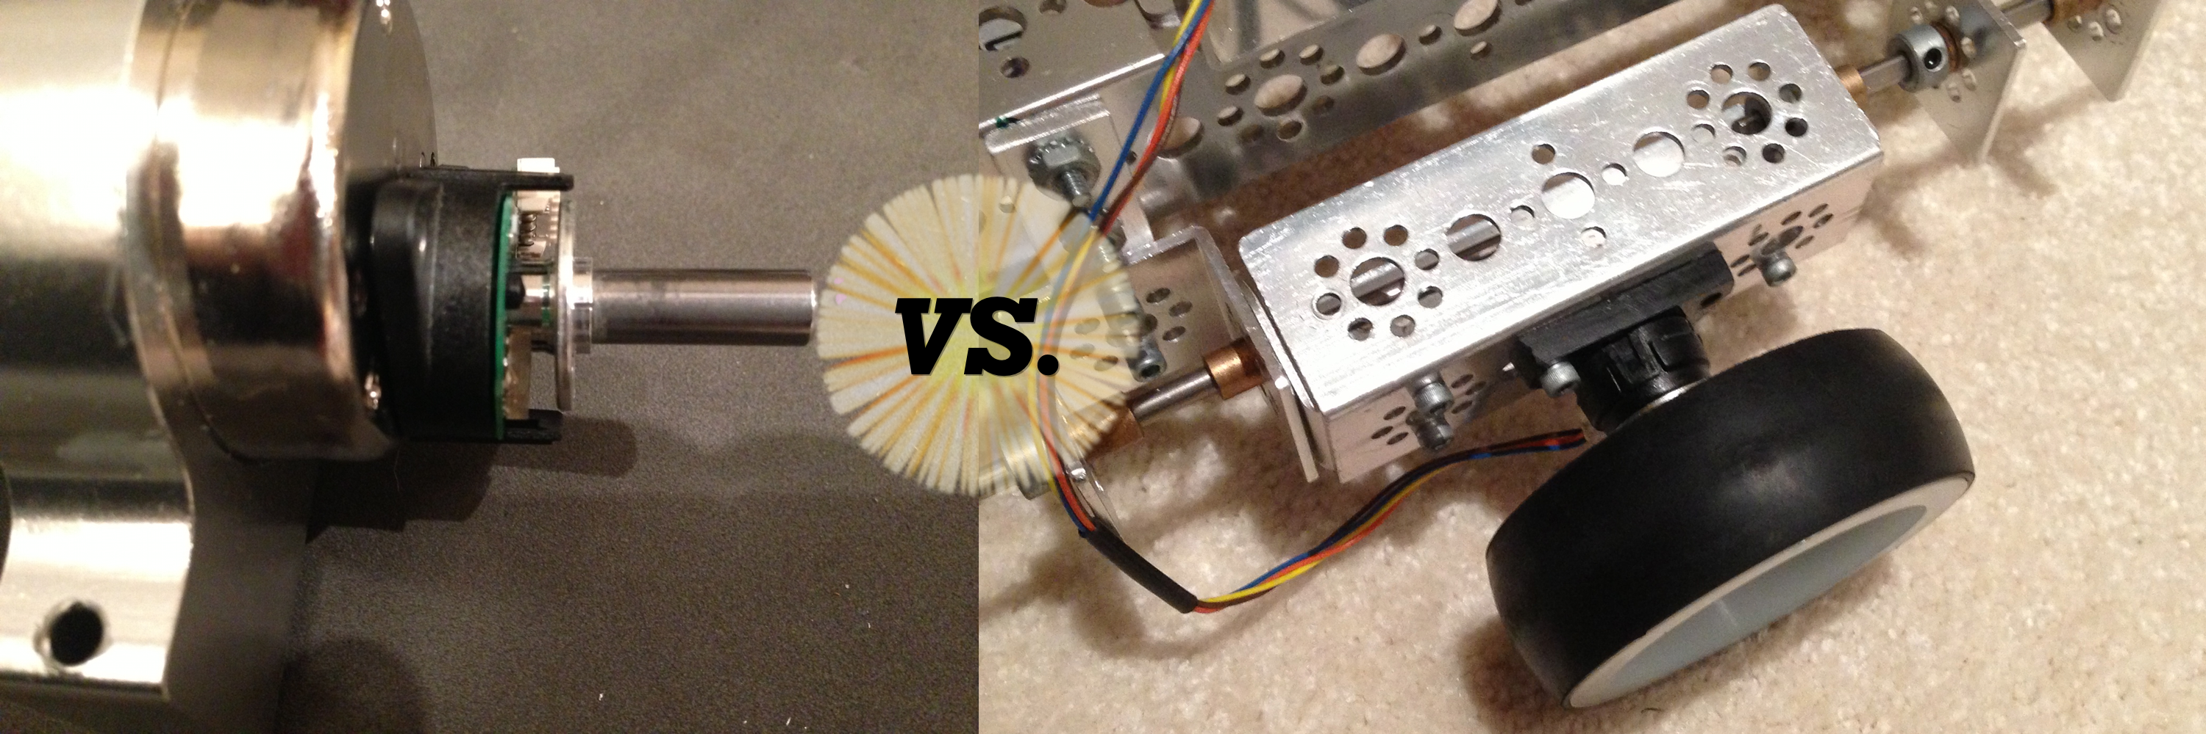

The third goal is achieved with three sets of equations:

* + - 1. Arc / Radius = Angle
      2. Arctangent
      3. Distance formula

Each achieves some part of the procedure outlined in “Procedure of Operation.” The distance formula returns goalDistance. Arctan returns goalAngle. Arc / radius the returns the robot current heading. The raw encoder reading returns current distance travelled.

Conclusions

Entach grants us the ability to autonomously move from point A to point B precisely which gives a great advantage in autonomous mode. Multiple points can be entered into one program. The only flaws with Entach are getting the radius from the center of rotation (which can be solved in part by taking a known angle and arc reading to get radius) and the fact that encoder disks aren’t 100% reliable (can be scratched). Entach’s precision is because of the virtually noiseless encoder. Entach can be placed anywhere on a robot. Entach can seamless translate x and y to motor movements. Future developments in Entach may lead to location tracking in TeleOp and / or in base that is strafing.

